Cube Build Design

Document created by: Cynthia Quejada

Date: 6/28/2016

Cube Build in Production: Friday, June 24, 2016

**Business Case:** Rebuilds Cube while users are still in the Cube. If the Cube needs manual reprocessing the users do not have to log out of the Cube. It will reprocess and display the latest version once the user logs back into the Cube.

**Design**

**Server location:** Hestia

Under PowerCubes, right click on the name of the Cube (Fianance Analysis) and then select “Properties”.

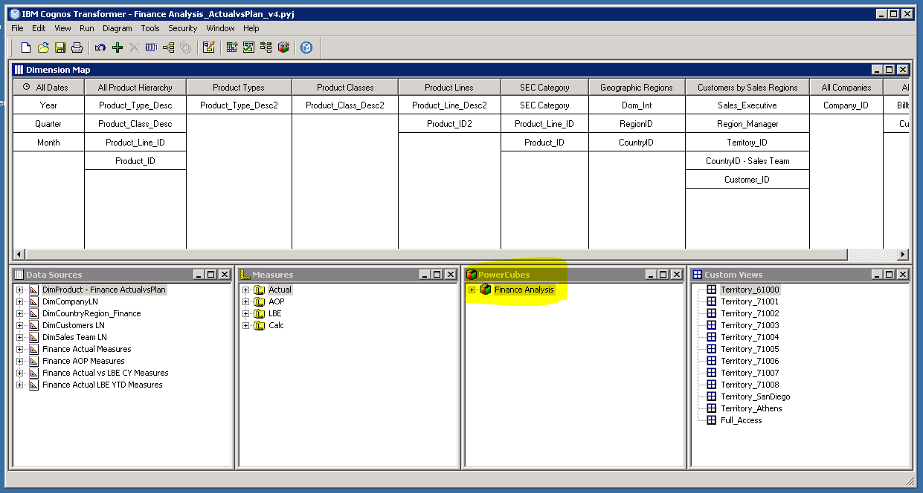

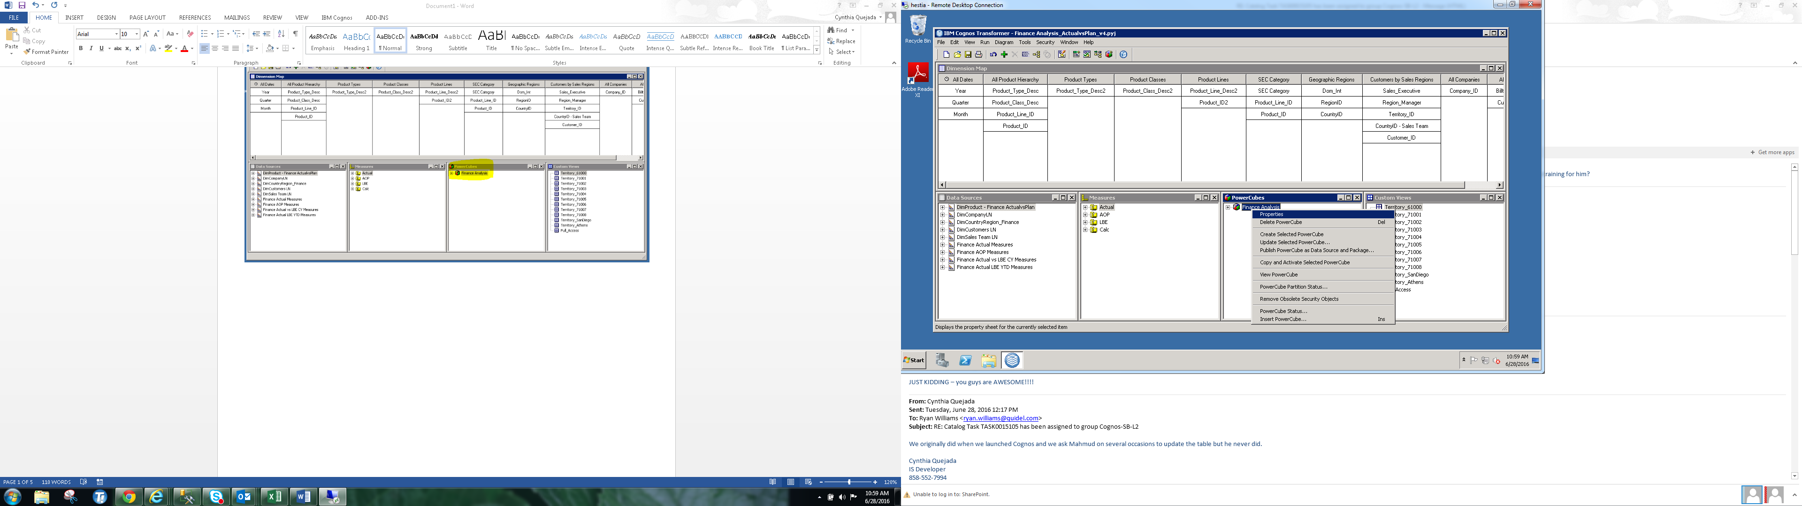

Click on the “Output” tab. There you will see the location where the cubes get built during the original cube build process which is at 2 am every morning and is kick off via ETL stored procedure. In addition, this is where the latest version of the cube is deployed if the cube needs to be manually reprocessed.

d:\cognos\transformer\cubes\build\finance analysis_actualvsplan.mdc

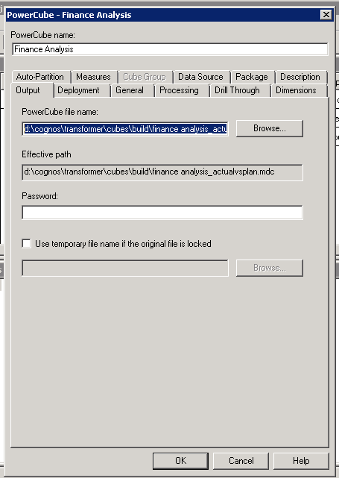

Under the “Deployment” tab you will find that the “build” file location is programed to keep 3 version of the cube, but only display the latest version.

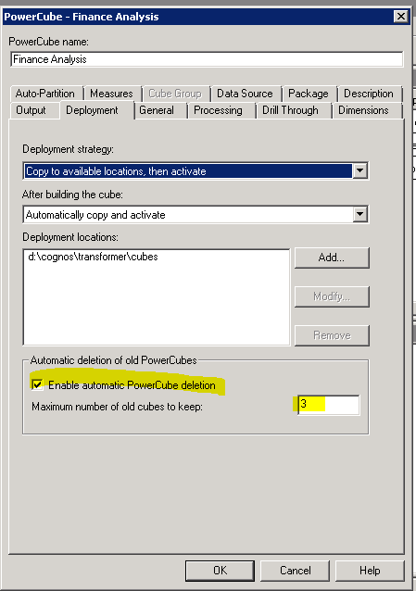

**Manual Rebuild of the Cube**

To manually rebuild the cube click on the “Create Power Cube” icon .

Once the cube has rebuilt you will get a message saying the build was successful.

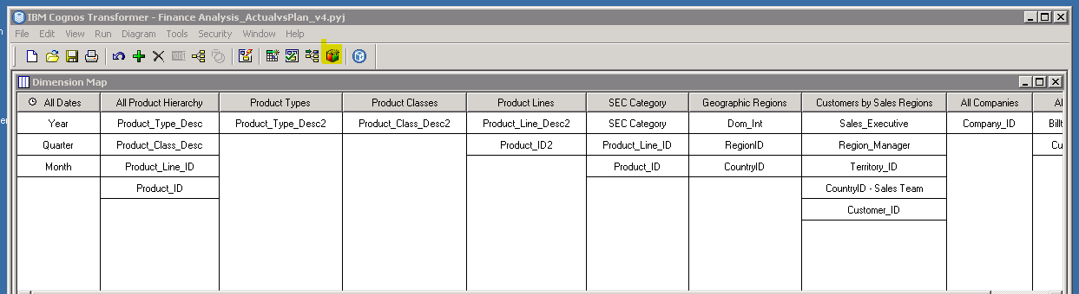

**To confirm the processed worked, access the below folder:**

D:\Cognos\Transformer\Cubes\build

Look at the “Date modified” for the Cube that was reprocessed. It should have the current date and time of when the cube was manually processed.

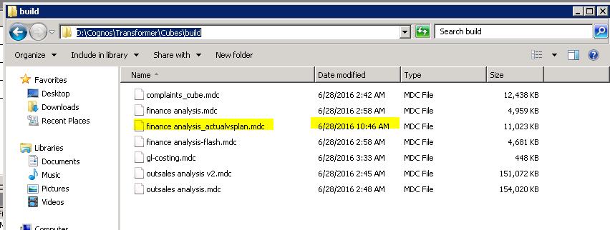

Next, check to make sure that a new file has been created with the latest version of the cube. The file will contain the name of the cube and the date and time it was created.

Users will have access to this version once they log into Cognos.

